**East West University**

**Department of CSE**

**PROJECT REPORT**

|  |  |
| --- | --- |
| **Course Code and Name:**  CSE251; Electronic Circuits | |
| **Project no:** 02 | |
| **Project name:**  Design a 5V DC Power Supply using Diode for a specified input. | |
| **Semester and Year:**  Spring 2023, 2023 | **GROUP NO: 08** |
| **Name of Student and ID:** | **Course Instructor information:**  M Saddam Hossain Khan(SHK)  Senior Lecturer  Department of Computer Science and Engineering  East West University |
| **Date of Report Submitted:** 19th May 2023 | |

**Problem Statement:**

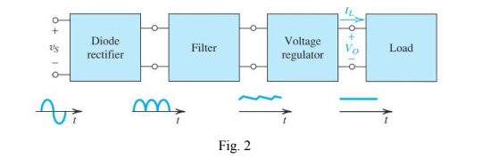

Fig.2 shows the block diagram of a dc power supply design process. The design process includes three design segments: a diode rectifier, a filter and a voltage regulator to get the final output Vo. The diode rectifier converts the input sinusoid Vs to a unipolar output, which can have the pulsating waveform indicated in Fig. 3. The variations in the magnitude of the rectifier output are considerably reduced by the filter block. The output of the rectifier filter contains a time-dependent component, known as ripple. To reduce the ripple and to stabilize the magnitude of the dc output voltage against variations caused by changes in load current, a Zener shunt voltage regulator can be implemented. Design the circuit components, and finally simulate to test the circuit. Use sine wave (24Vp-p) as input signal, and capacitor, resistors and Zener diode of suitable value for the design. Note that, for design purpose, the values of the resistors should not exceed more than 10kΩ.

**Design Details:**

Step 1 (Diode rectifier):

There is a 24v peak to peak sinusoidal wave as input and we have to convert that input into a stable 5v output. First, we have to convert the sinusoidal waveform to only positive cycle. For this we have used a bridge rectifier using 4 diodes (D1N4002). This was our diode rectifier part.

Step 2 (Filtered plot):

Then we have added a high value capacitor in parallel with the bridge rectifier to reduce the variations in the magnitude of the rectifier output. We have used a 470 micro farad capacitor so that the ripple will be very small (0.3v).

Step 3 (Voltage regulator):

To reduce the remaining ripple and to produce a constant voltage in the output we have used a Zener diode (D1N750) in reverse biased mode. We have set the value of Zener diode breakdown voltage so that we can get a regulated 5v output.

**Circuit Diagram:**

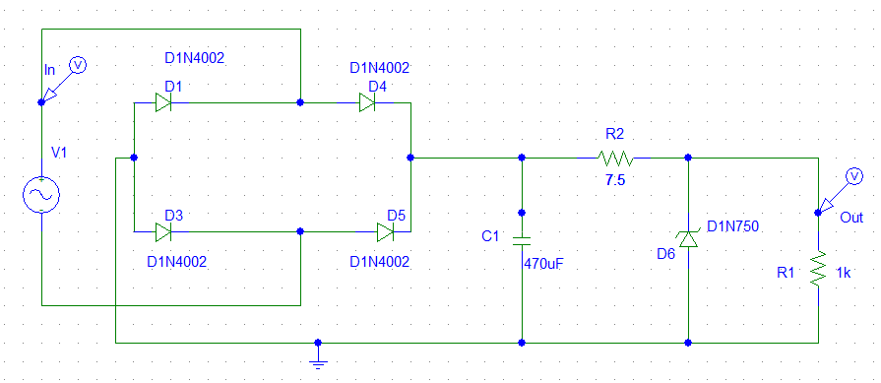

**Fig 1:** Complete circuit diagram.

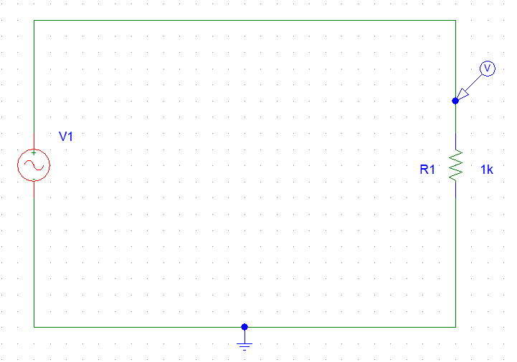

**Fig 2:** Input signal circuit.



**Fig 3:** Output signal.

Step 1 (Diode rectifier):

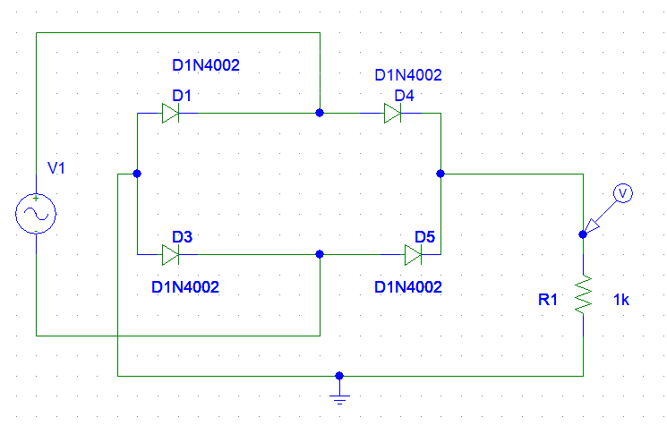

**Fig 4:** Diode rectifier plot circuit.



**Fig 5:** Diode rectifier output plot.

Step 2 (Filtered plot):

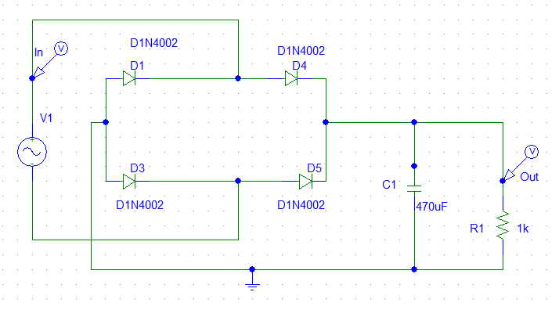

**Fig 6:** Filtered plot circuit.



**Fig 7:** Input vs filtered output.

Step 3 (Voltage regulator):



**Fig 8:** Voltage regulator circuit.



**Fig 9:** Input vs regulated output.

**Theoretical Value:**

Here,

R1= 1kΩ

R2= 7.5 Ω

f = 0.5 kHz

Vr = 0.24v

ID =100mA

We know that,

$C=\frac{I}{2fVr}$

$→C=(\frac{100}{2*500*0.24}$)

$$∴C=470 uF$$

**Discussion:**

We are targeting a pick to pick ripple around 10 mv and considering maximum load current 30 mA and frequency 0.5 kHz. The value of the capacitor is chosen based on the expected load current and the desired ripple voltage. We will use a 470 uF capacitor for this design. Which will provide a ripple voltage of approximately 0.24V (assuming load current of 100mA).

**Conclusion:**

Therefore, we have found DC power supply by using a full wave rectifier (Bridge), Capacitor to filter the output and finally 7.5Ω resistor with a Zener diode as a voltage regulator. Here bridge rectifier (4 diodes) converts full wave to half wave signal. Then 470uF capacitor to reduce the vibrate in the magnitude of the rectifier output. Last the Zenar diode break down the voltage. Therefore, we will get our expected output.